**VIBER**

**WEB APPLICATION**

**Rakuten viber is a cross-platform voice over IP and instant messaging software. It is provided as freeware for Android, Windows, iOS, MacOS and Linux platforms.**

**1.After opening the viber website we can download it in the windows by clicking on the “Download Viber” button in the homepage.**

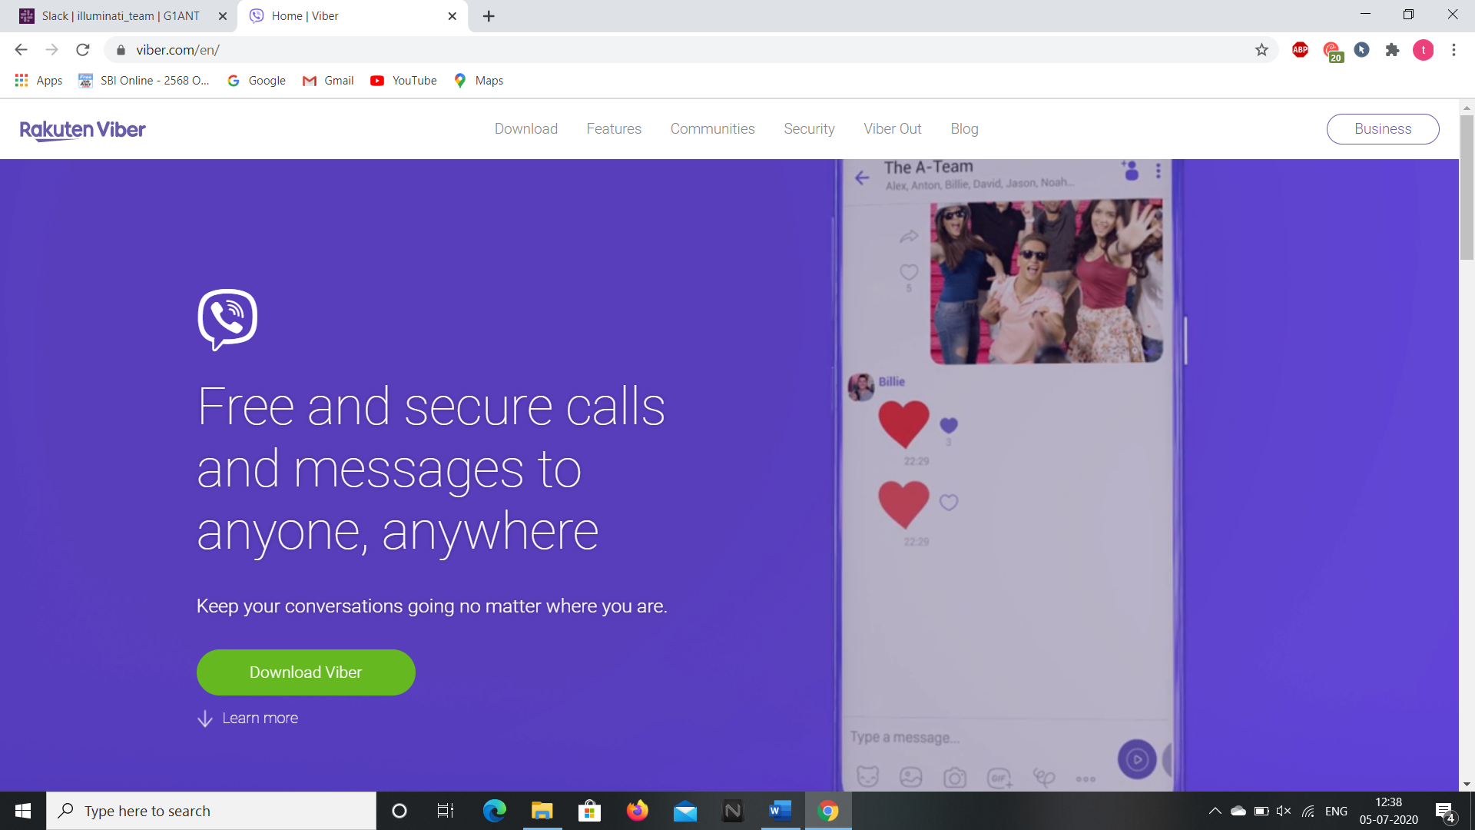

**2.We can download viber for desktop for windows and for Mac as well as for android through Play store.**

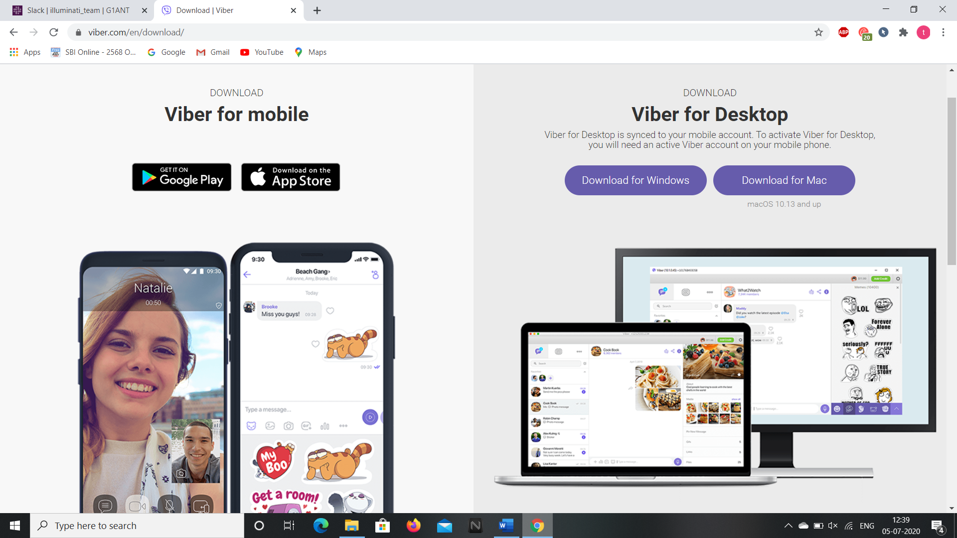

**3.By clicking on the “Features” button in the home page we can get to know the features relating to security, quality, extensions and community.**

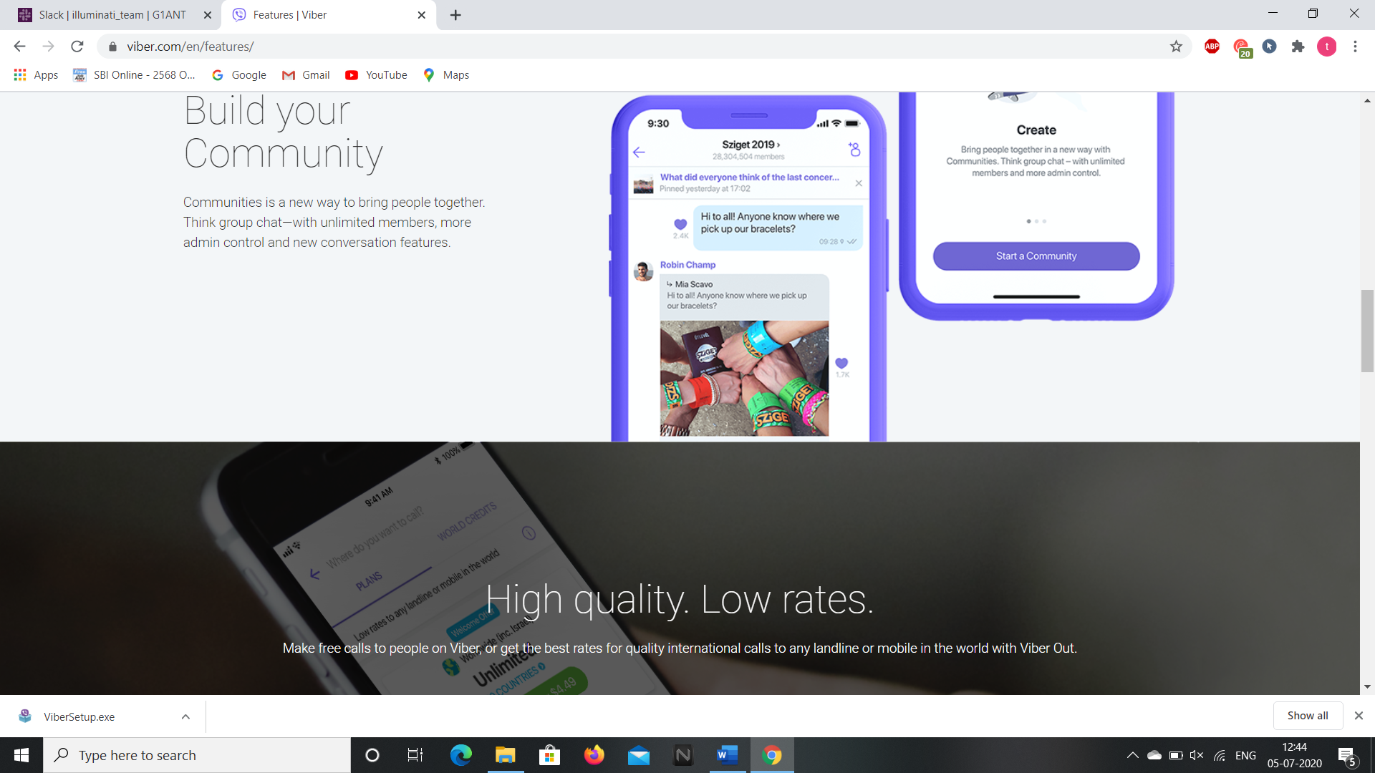

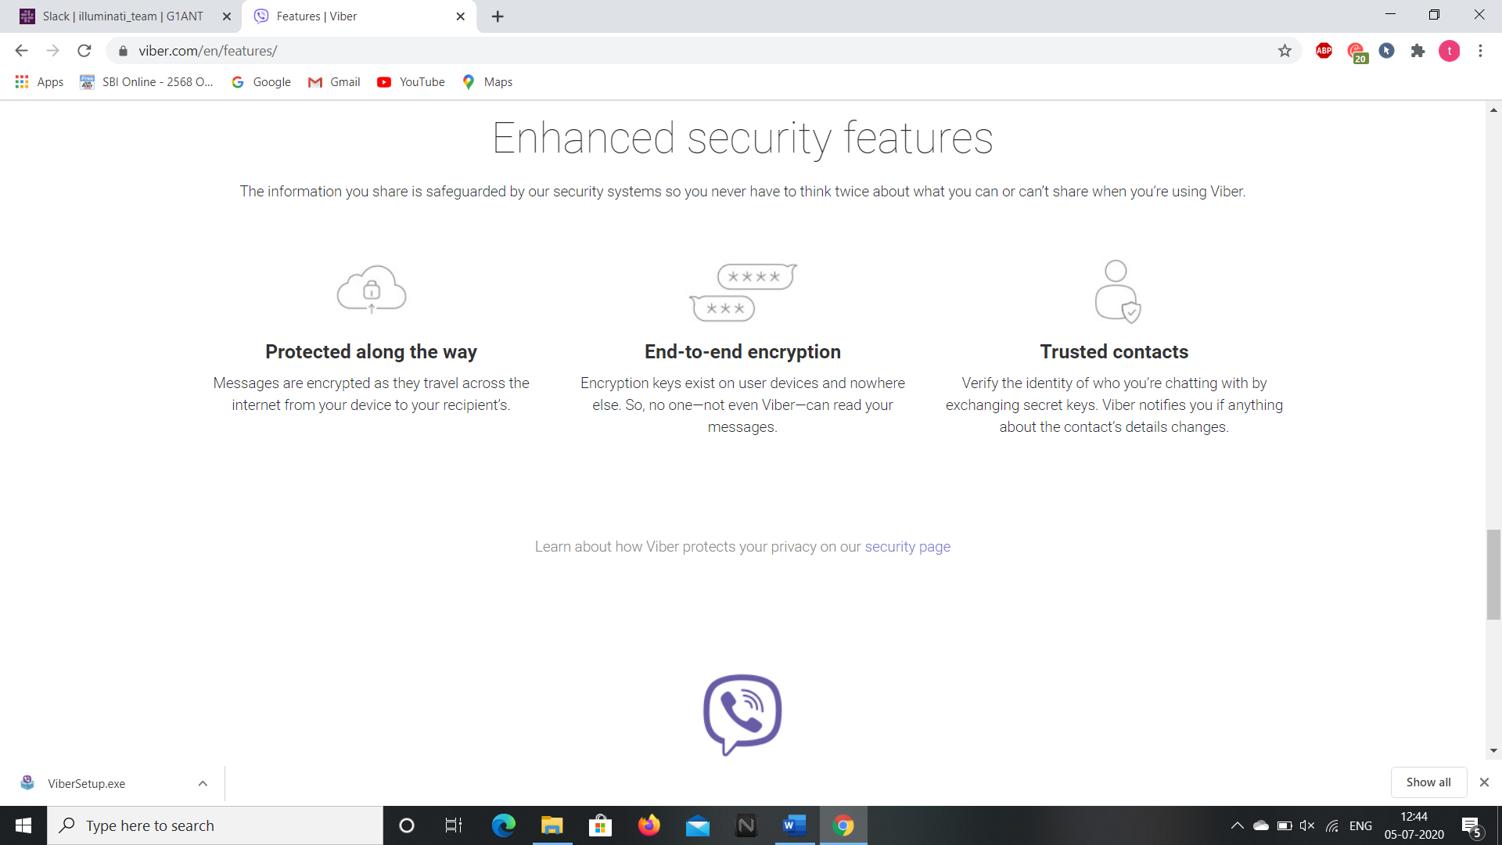

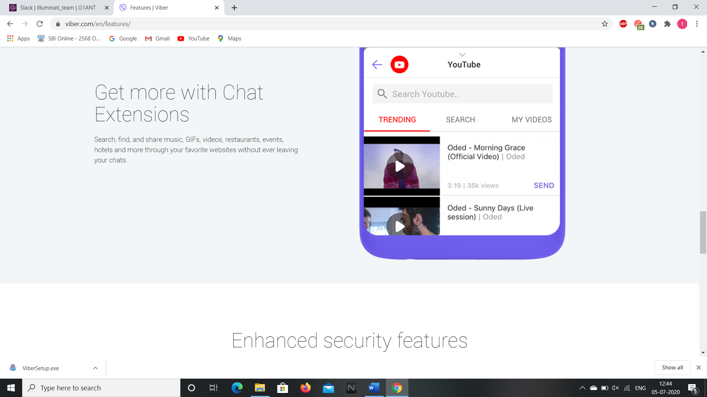

**4.By clicking on the “Communities” section we can start a community and get insights of it.**

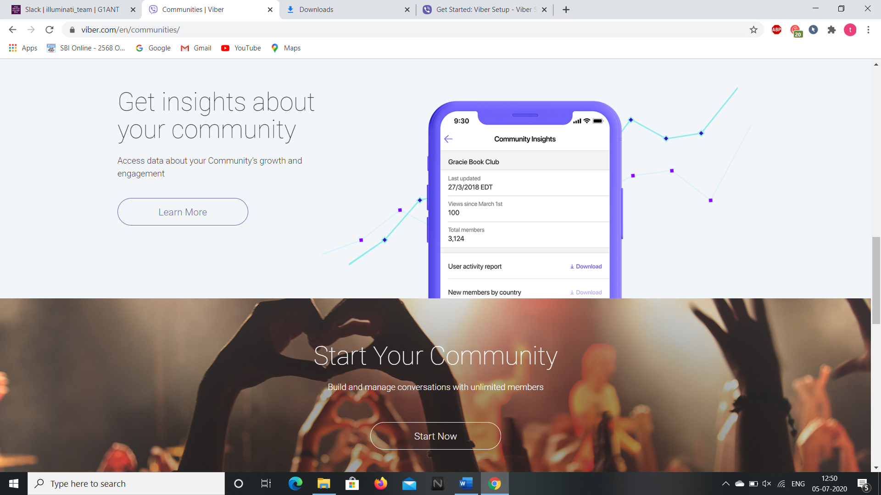

**5.By going to the “Security” section we can get the information about privacy and extra features of it.**

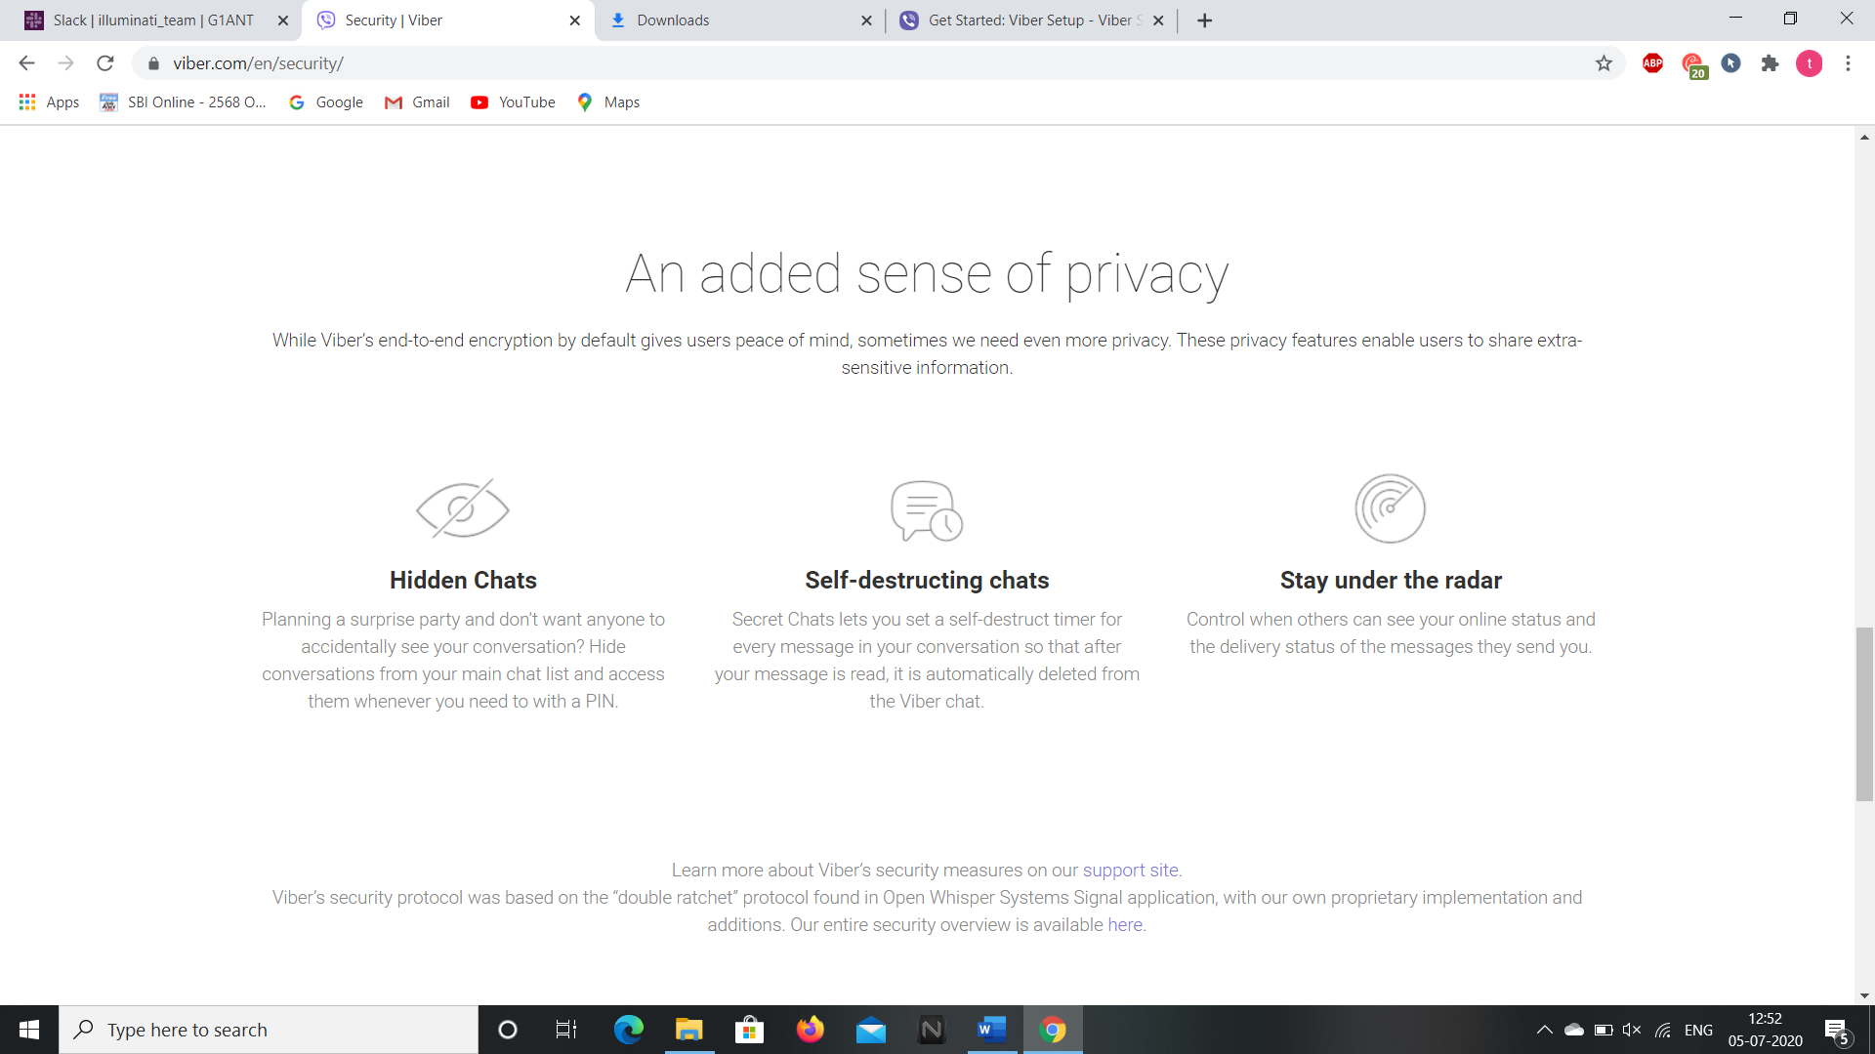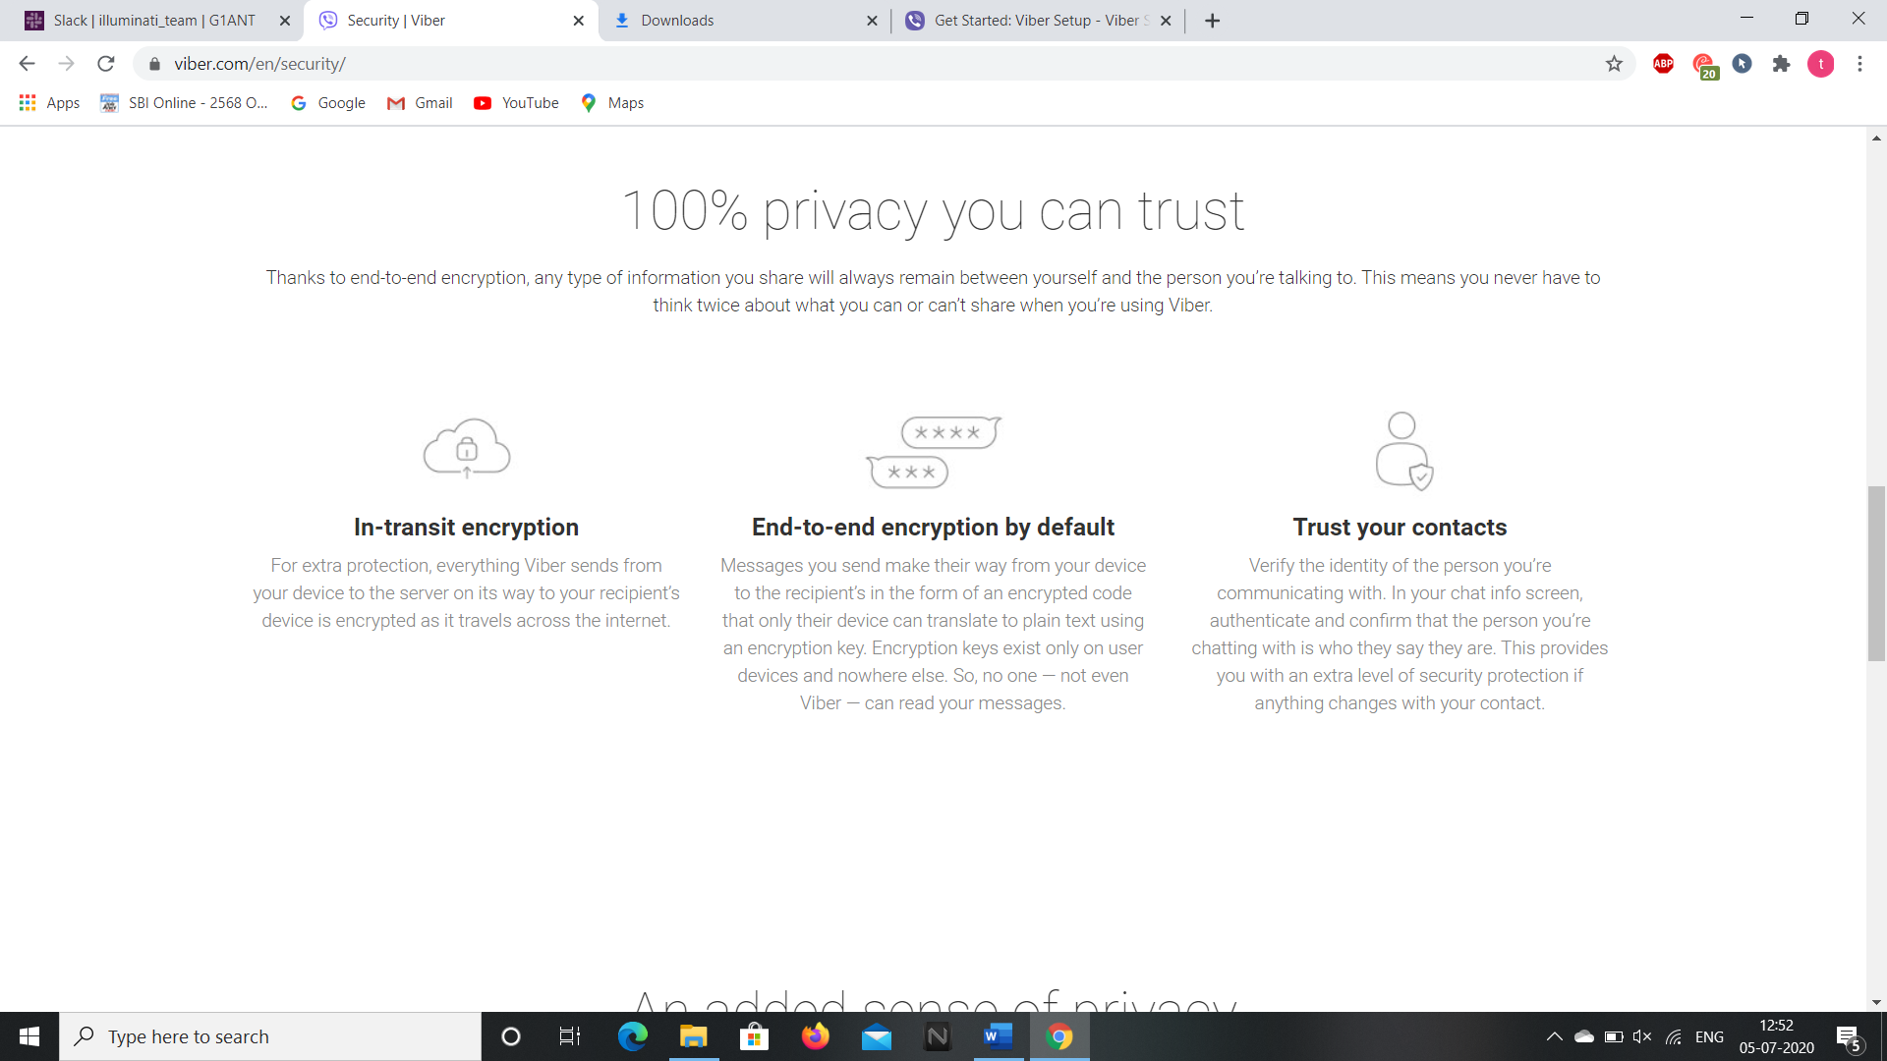

**6.By clicking on the “Viber Out” section we get information on usage of international calls in viber.**

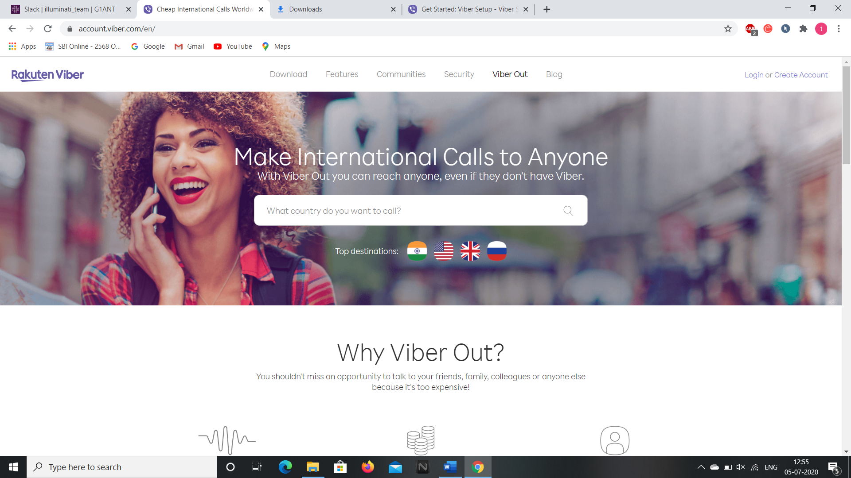

**7.Clicking on the “Blog” section we are redirected to the blog page of viper and we can get information of Business, Calling Guides, Culture & Lifestyle, Feature & Tips and News of viber by clicking on them.**

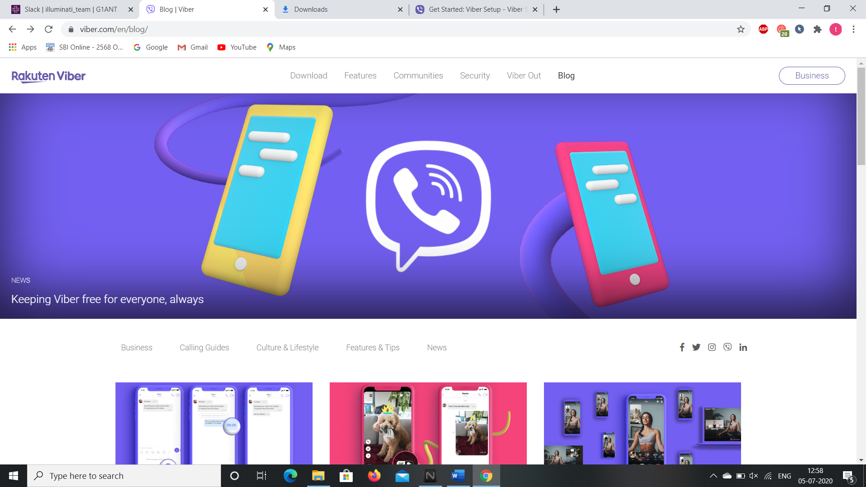

**8.After installing the Viber for desktop we can access it by scanning the QR Code through the android application.**

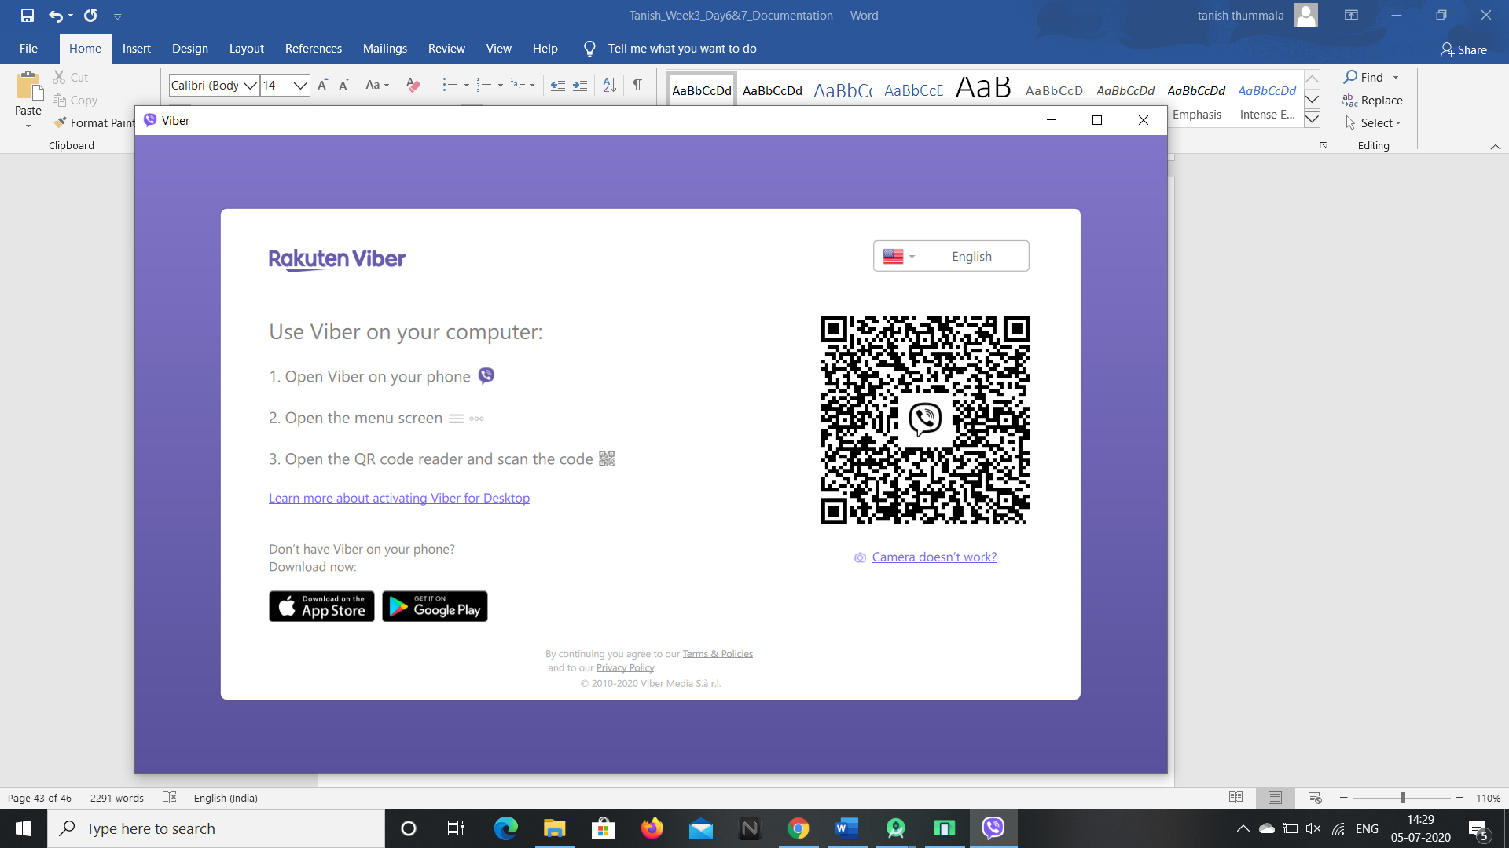

**So generally viber is an android application software and can be accessed in desktop after downloading the android application in your phone and scanning the QR Code.**

**So this is the way we can access the contents of this web application and we can access the webpage through selenium addon as well. Now, let’s see the android application of it.**

**ANDROID APPLICATION**

**We can download the android application through “Google Play Store” and installing it in the Virtual Phone through Android Studio.**

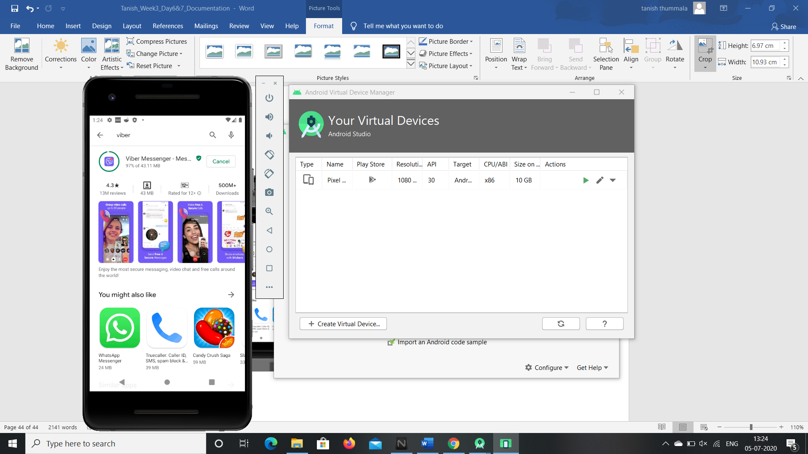

**1.After installing open the app and click on continue button then give your phone number and type the OTP send to your phone.**

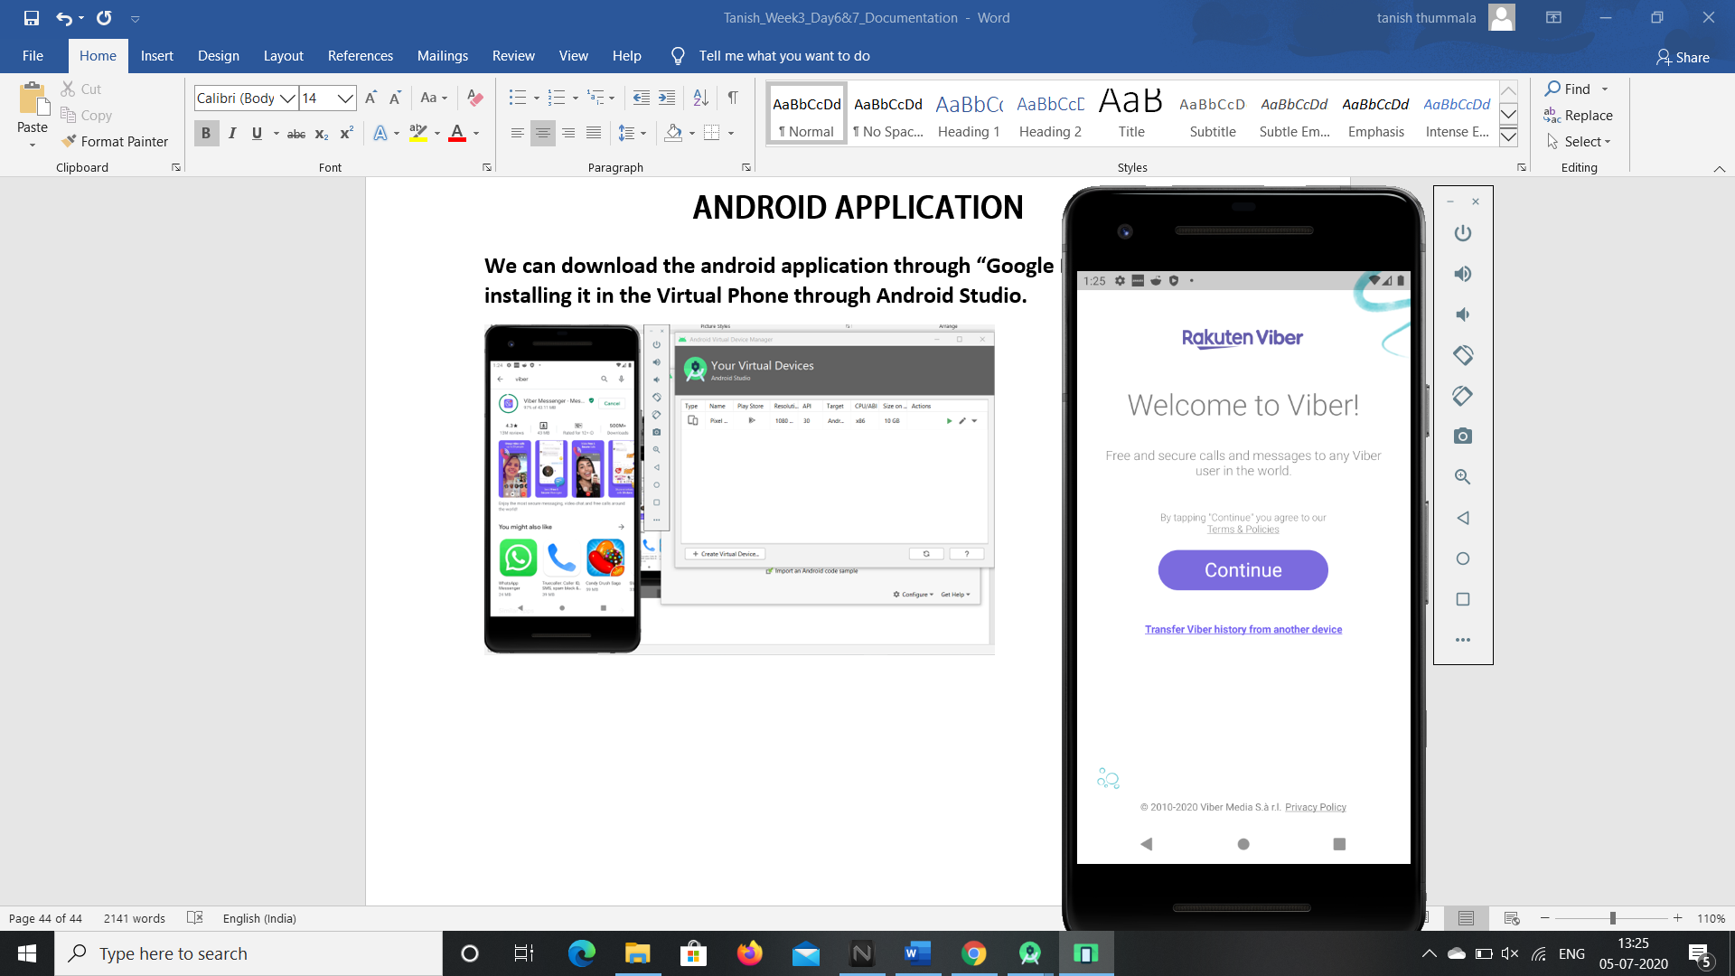 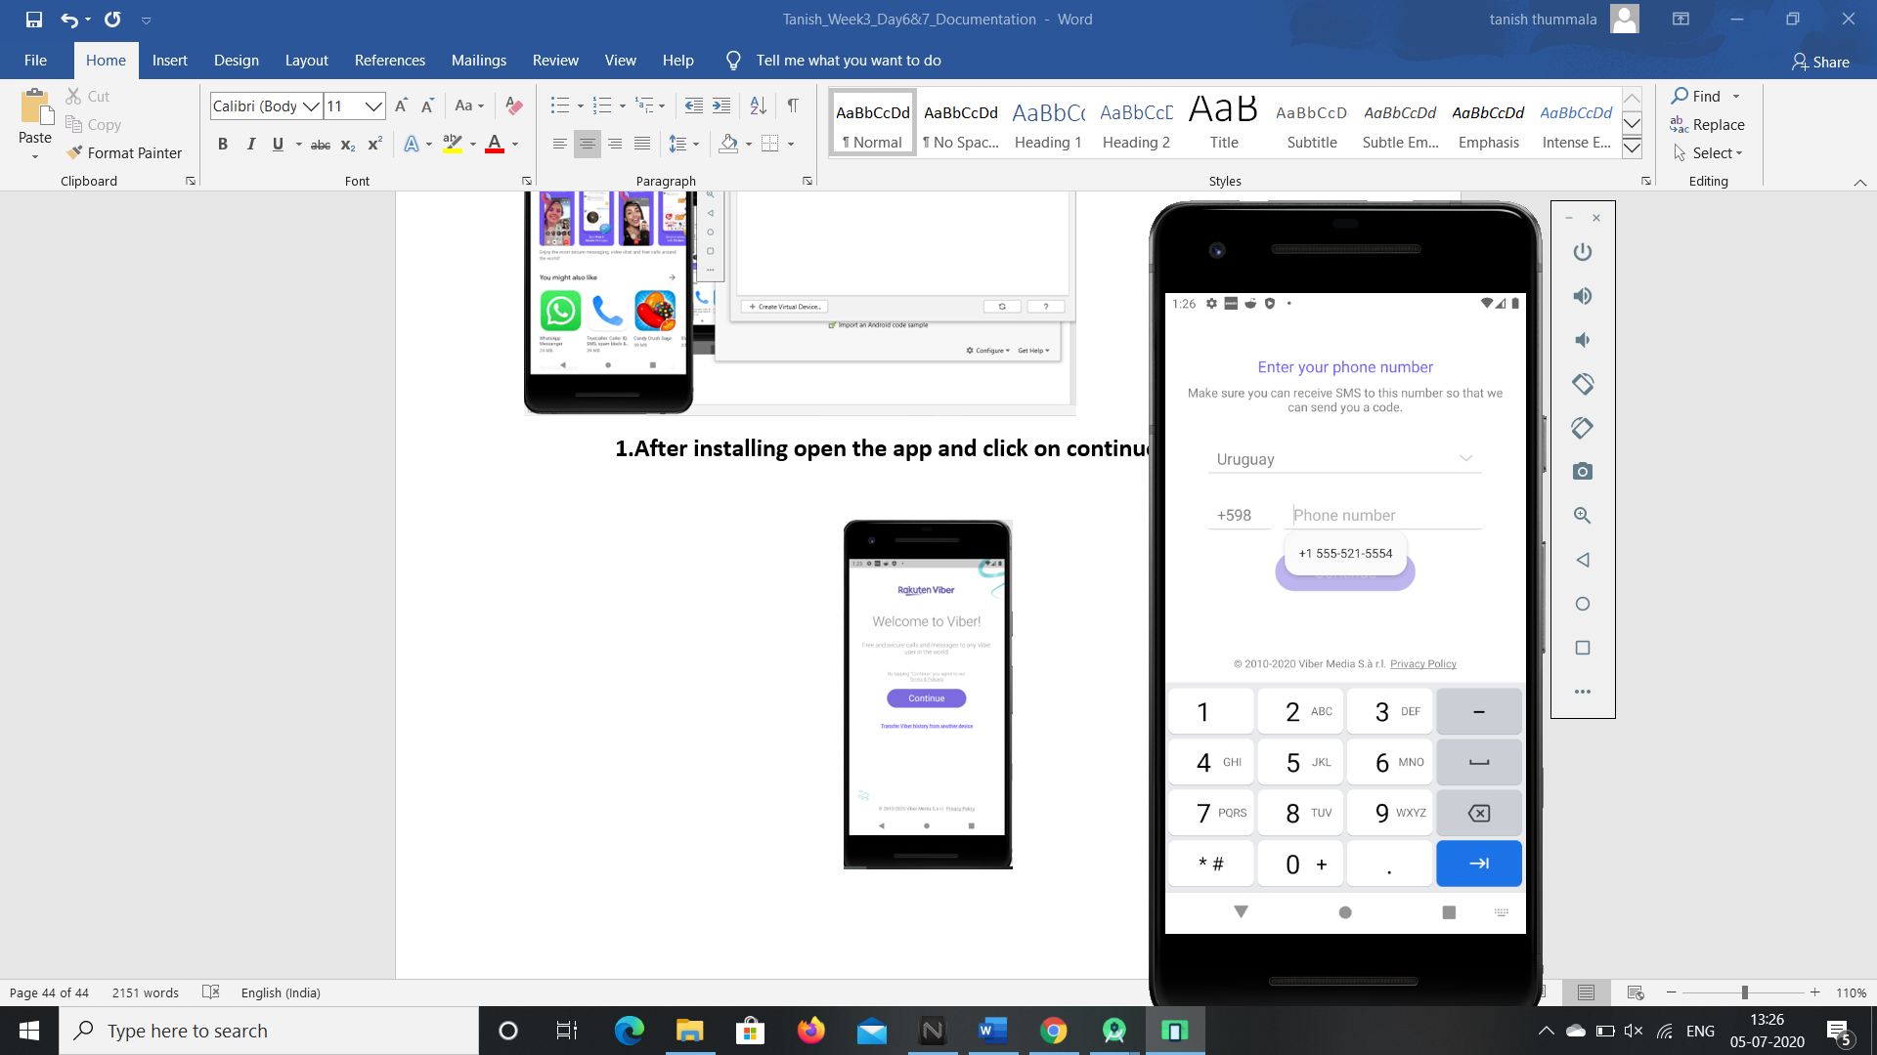 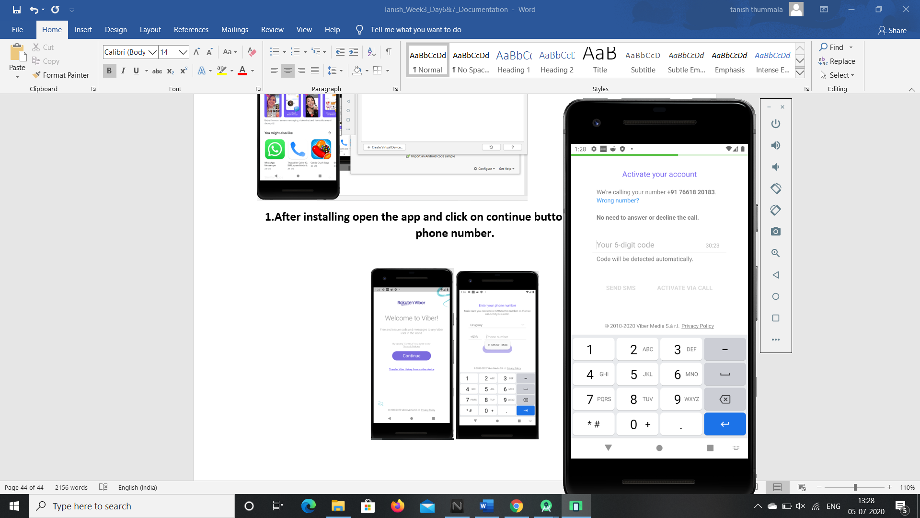

**2.Then give your details of your profile like your full name, DOB and Email.**

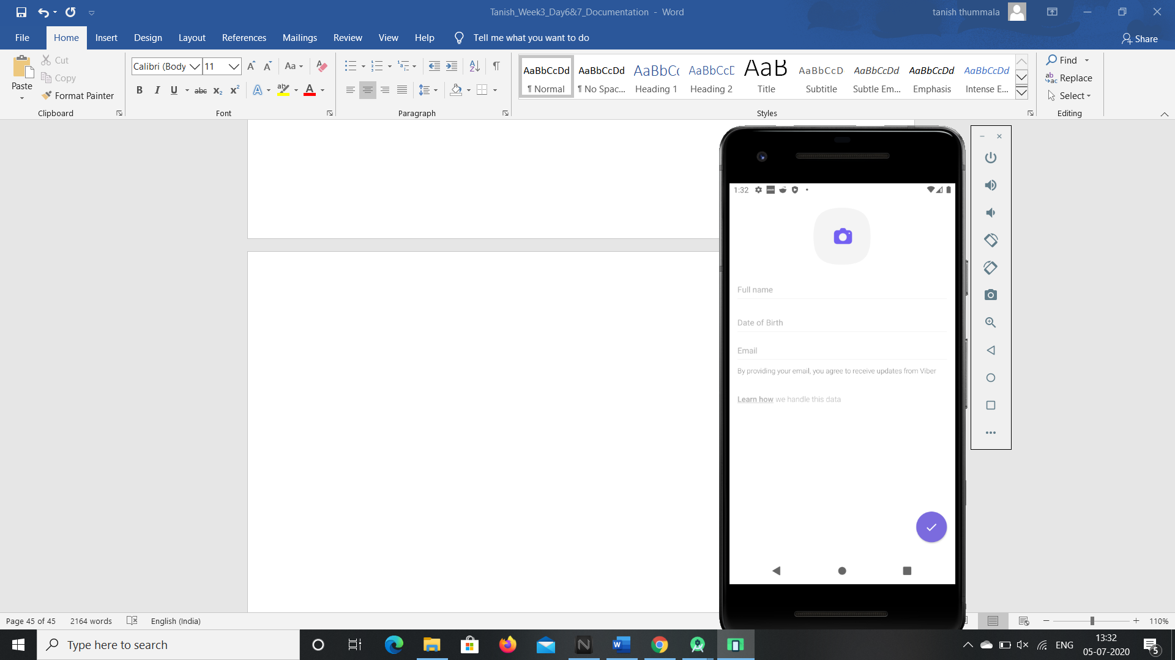

**3.So your viber app opens up and with the recent chats page showing up.**

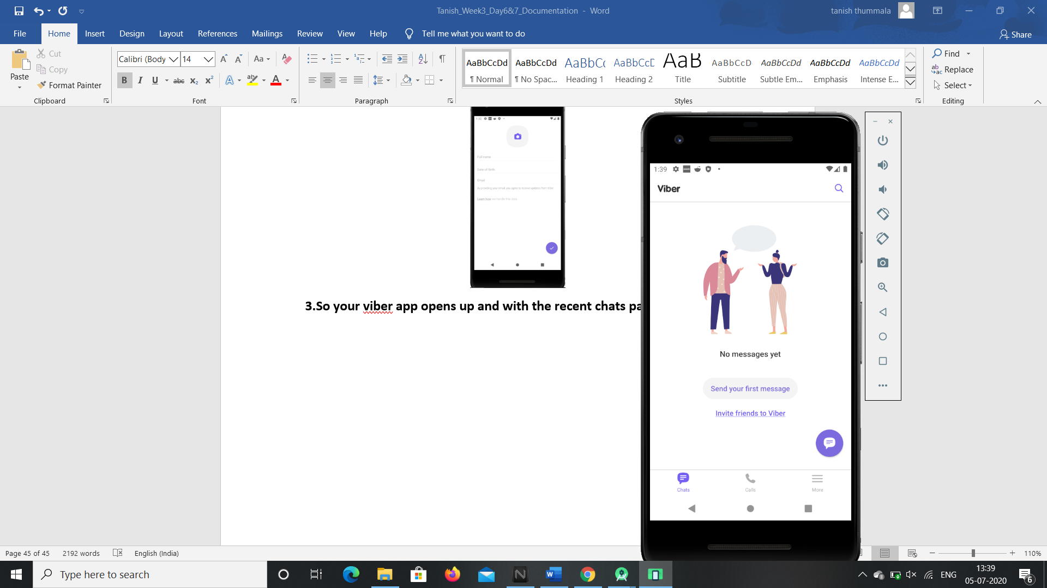

**4.By clicking on the search button we can search the messages or chats in viber community.**

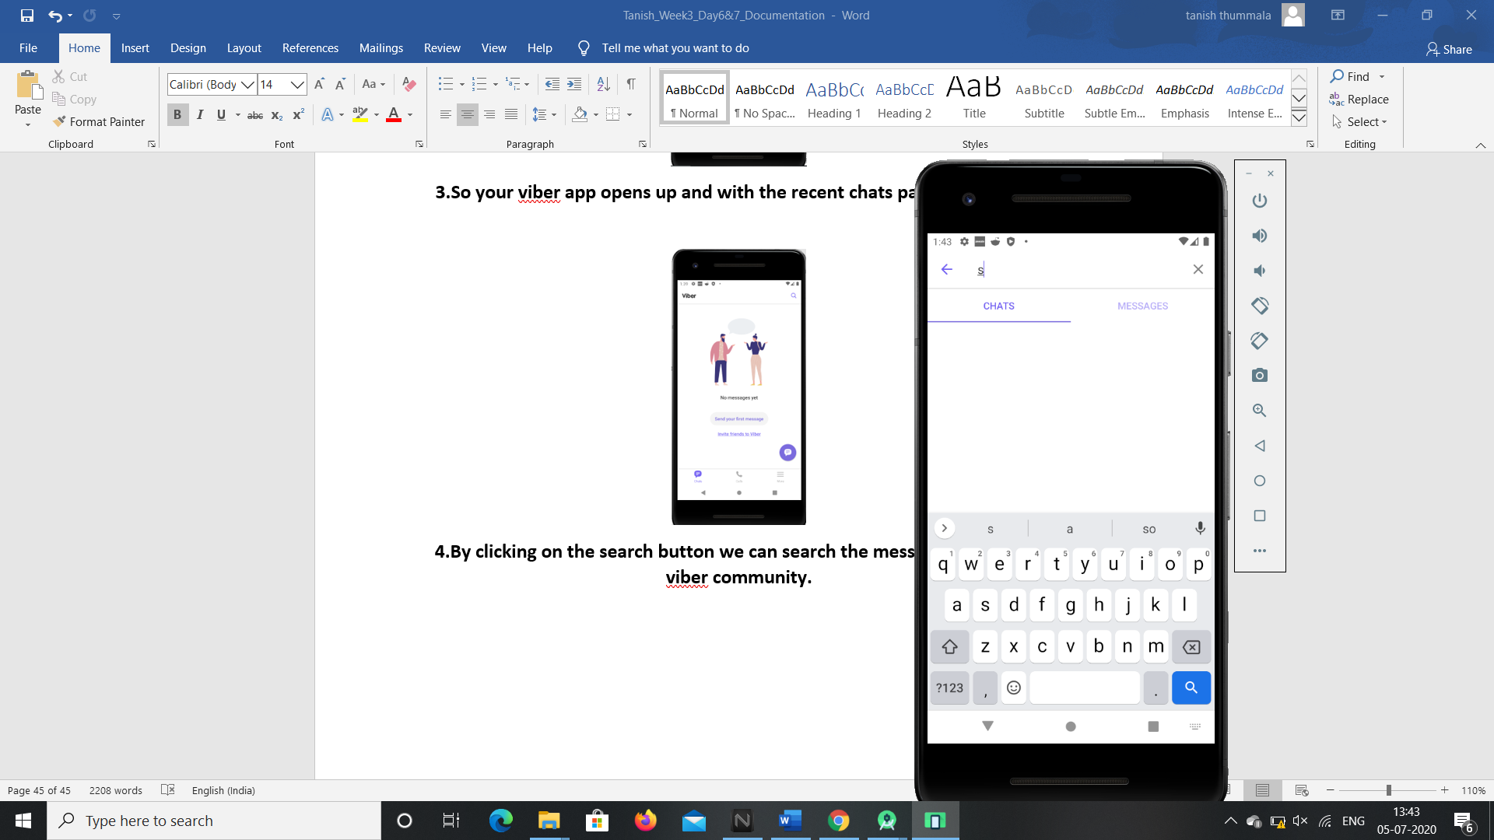

**5.We can check our contacts and contact anyone by clicking on the calls button after syncing it through our email.**

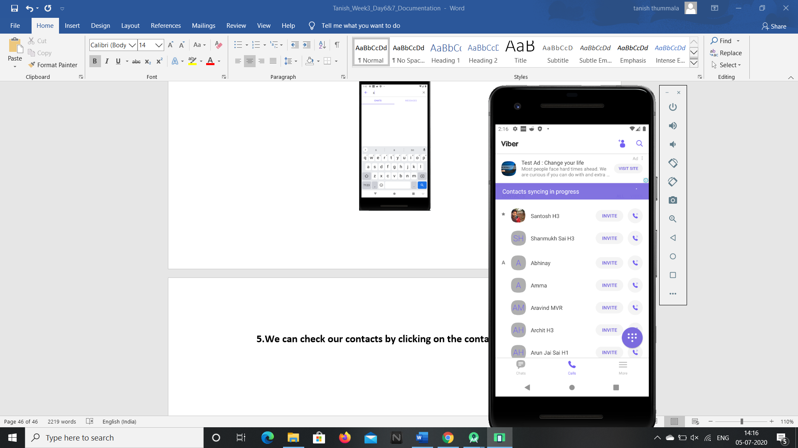

**6.We can check our profile details by clicking on the more button.**

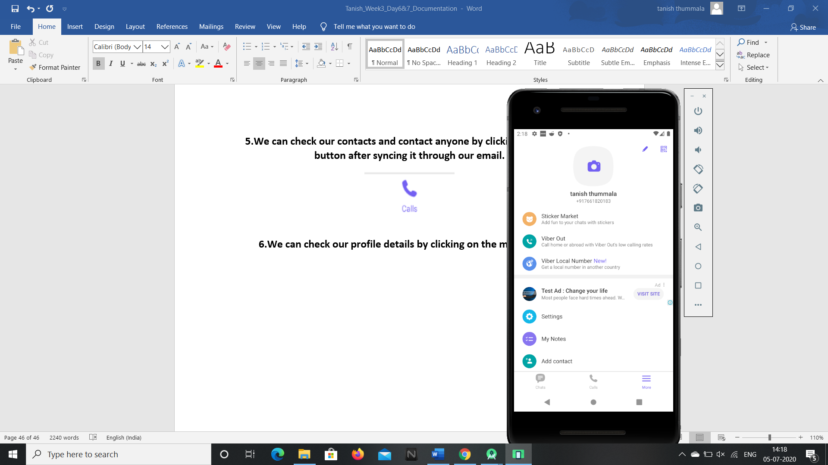

**7.We can edit our profile details by clicking on the edit button in the profile home page.**

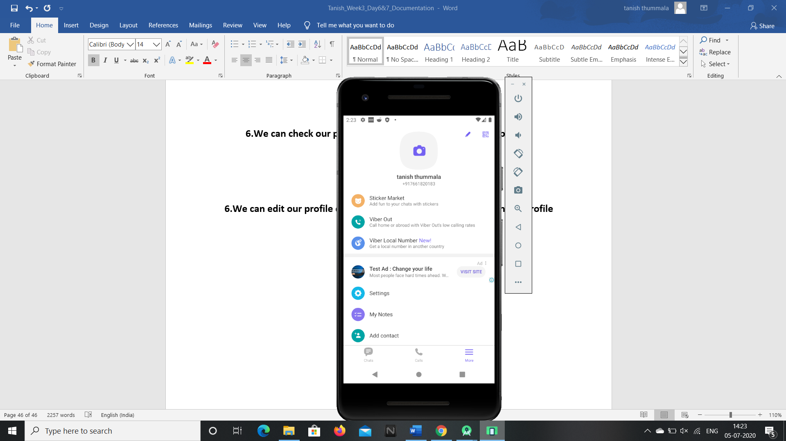

**8.We can scan our QR code details by clicking on the QR button in the profile home page to access Viber Desktop.**

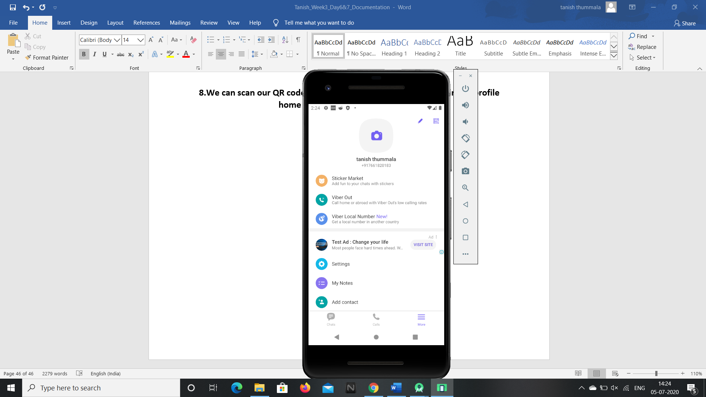

**The above icons will show the privacy and secrecy details of a member.**

**So these are the features present in the viber android application and these can be accessed by G1ANT Robot through Appium addon.**